Exercise 7: Implementing Constructor and Setter Injection
Scenario:
The library management application requires both constructor and setter injection for better control over bean initialization.

Implementation:
- Configure Constructor Injection:

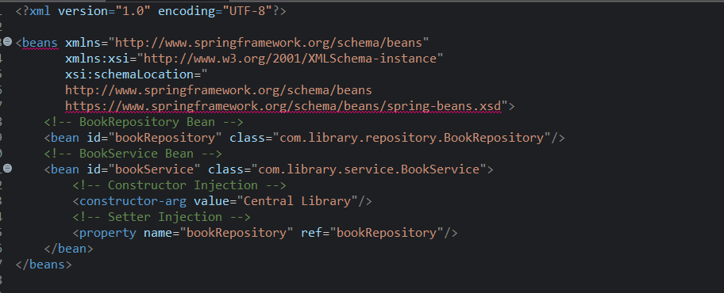

- Configure Setter Injection:

BookRepository.java

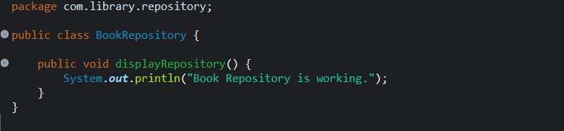

BookService.java

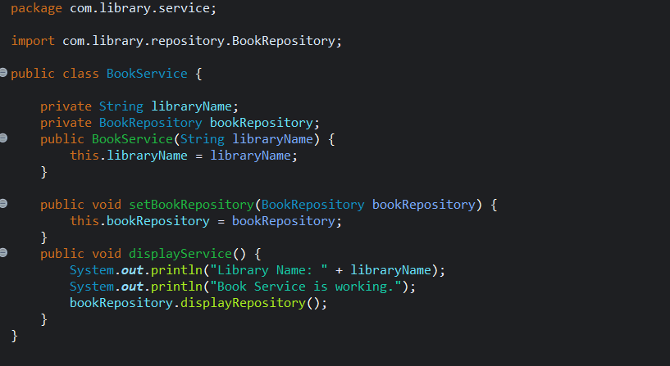
- Test the Injection:
LibraryManagementApplication.java

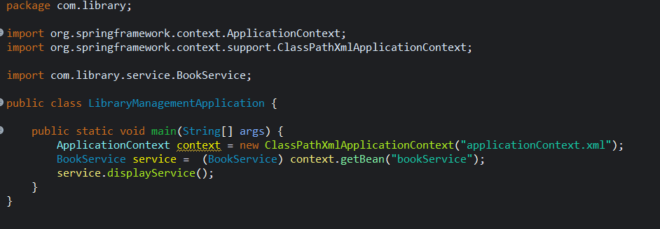

OUTPUT:

